Section Title

This is used for chapter titles and such.

# Header

This is used for overarching sections of a chapter.

|  |
| --- |
| Subheader |

This is used for class features and subclass titles. The line is created with a table and the spacing with the first paragraph, so it is important that you copy this section exactly. Always use the formatting for this paragraph for the first paragraph after the heading,

And always use the formatting for this paragraph for all paragraphs after the first one.

### Small Header

This is used for sub-class features.

The second paragraph in a block of text always has the first line indented by three spaces, or .13 inches.

***Mini-Section.***  These are used for small sections. Make sure to include the three spaces or .13 inch indent.

###### Mini-Mini-Section. These are used for sections within mini-sections. They have a hanging indent and a 4 pt space before the first one.

###### Mini-Mini-Section. Here’s one without the spacing before or after.

###### Mini-Mini-Section. The last mini-mini-section in a series has a 4 pt space after it.

### Miscellaneous Formatting

**Stats Headers:** These are used for mechanical sections, with a colon instead of a period and no italicization. They have a hanging indent.

Bulleted lists are formatted as follows:

* There is a 4 pt space before the first list item
* There is no space before or after the middle items
* There is a 4 pt space after the last list item.

Roll formulas are presented as follows:

**Spell save DC** = 8 + your proficiency bonus

+ your Charisma Modifier

For all other style tips (such as capitalization, naming, etc) reference [Anathemys’ Style Guide.](https://www.reddit.com/r/UnearthedArcana/comments/3rjovn/unofficial_phb_style_guide_you_must_finish_a_long/)

# Tables

Tables have styles. The color should match the sidebars.

**An Interesting Table Title**

|  |  |
| --- | --- |
| **First Column** | **Second Column** |
| 1st | First column is centered |
| 2nd | Second column is left-aligned |

|  |  |  |  |  |
| --- | --- | --- | --- | --- |
| **d10** | **Background Types** |  | **d10** | **Background Types** |
| 1 | Ancestral |  | 6 | Elemental |
| 2 | Fey |  | 7 | Undead |
| 3 | Troll |  | 8 | Merman |

|  |  |
| --- | --- |
| **d6** | **Backgrounds Chart** |
| 1 | First column is centered |
| 2 | Second column is left-aligned |

# Sidebars

|  |
| --- |
| **Sidebar Text - Green (used in most of the phb)**  This is sidebar text, which, along with tables, is in a different font from other text. Google docs sidebars are never going to be as fancy as word, but they get the job done. |

|  |
| --- |
| **Sidebar Text - Brown (used in appendixes)**  This is sidebar text, which, along with tables, is in a different font from other text. Google docs sidebars are never going to be as fancy as word, but they get the job done. |

|  |
| --- |
| **Sidebar Text - Purple (used in spells)**  This is sidebar text, which, along with tables, is in a different font from other text. Google docs sidebars are never going to be as fancy as word, but they get the job done. |

# Class Tables

|  |  |  |
| --- | --- | --- |
| **Class Table — Single Column Width** | | |
|  | **Proficiency** |  |
| **Level** | **Bonus** | **Features** |
| 1st | +2 | This class table is used for classes |
| 2nd | +2 | That only need one column of space. |
| 3rd | +2 |  |
| 4th | +2 |  |
| 5th | +3 |  |
| 6th | +3 |  |
| 7th | +3 |  |
| 8th | +3 |  |
| 9th | +4 |  |
| 10th | +4 |  |
| 11th | +4 |  |
| 12th | +4 |  |
| 13th | +5 |  |
| 14th | +5 |  |
| 15th | +5 |  |
| 16th | +5 |  |
| 17th | +6 |  |
| 18th | +6 |  |
| 19th | +6 |  |
| 20th | +6 |  |

Unfortunately, google docs doesn’t support pages with multiple layouts. To compensate for this you can create a similar layout to the double column class table with two modified single-column tables next to each other, as is demonstrated on the next page. You must make sure that the two tables are lined up exactly if you copy paste-them (which you must do individually.)

|  |  |  |
| --- | --- | --- |
| **Class Table — Double Column Width** | | |
|  | **Proficiency** |  |
| **Level** | **Bonus** | **Features** |
| 1st | +2 | This class table is used for classes |
| 2nd | +2 | That need two columns of space. |
| 3rd | +2 |  |
| 4th | +2 | Delete columns you don’t need on the right, |
| 5th | +3 | Then select the whole right side and right click, |
| 6th | +3 | And select “Distribute Columns.” |
| 7th | +3 |  |
| 8th | +3 |  |
| 9th | +4 |  |
| 10th | +4 |  |
| 11th | +4 |  |
| 12th | +4 |  |
| 13th | +5 |  |
| 14th | +5 |  |
| 15th | +5 |  |
| 16th | +5 |  |
| 17th | +6 |  |
| 18th | +6 |  |
| 19th | +6 |  |
| 20th | +6 |  |

When you get to the end of this column, be sure to skip to after the table in the next column before continuing to write

I think the easiest way to use this template is by making a copy, and then starting your own writing on the blank page at the end of this document, and then copying down from these pages until you’re done, then deleting these..

# Images

To insert your own image, click the image to the right and click “edit.” Right click the drawing > Order > Send to Back to get the border out of the way. Then, right click the image and click “replace image.” Replace the image with a 3:2 aspect ratio image of your choice. When you’re done, right click the image > Order > Send to Back to put it back behind the border.

If you find that your image is blurry like the one to the right and you plan to present this document in google docs, go [here](https://www.artstation.com/artist/rutkowski&t=YTE4OTk3MDdiZjM1YzEwZjY5ZTE4ZjhkZTUzMGQ5OTE2ODA2YWUyMCxMaXBobGp4bQ==&b=t:u_-yZvWdEHOYXlq1kG-WZw&p=http://rpg-settings.tumblr.com/post/160099887267/ravensshire&m=1) and compress the image then re-upload it. You should also use the [versions of these drawings with compressed borders](https://docs.google.com/document/d/1c88Zp43_xKtkIIU2DDQ5n01LZ47oSUv0IwI3goiNOw0/edit?usp=sharing). You can also download the drawing as an image and then upload that and place it in the document instead.

If you’re going to download the document as a PDF, don’t worry because in the PDF the images will be much clearer.

On the next page are a few more image frames which work the same way, but with a different aspect ratio that is noted. To make an image able to span both columns, click the image and select “Wrap Text” or “Break Text.”

For the images with background splatters your image needs to have a transparent background. You can remove the background from your image [here](https://burner.bonanza.com).

You’ll have to ensure there are enough lines of text or returns in this area when you add text to make the two halves of the table line up.

|  |  |  |  |  |
| --- | --- | --- | --- | --- |
|  |  | | | |
| **Cantrips** | **Spells** | **Spell** | **Slot** | **Invocations** |
| **Known** | **Known** | **Slots** | **Level** | **Known** |
|  |  |  |  |  |
|  |  |  |  |  |
|  |  |  |  |  |
|  |  |  |  |  |
|  |  |  |  |  |
|  |  |  |  |  |
|  |  |  |  |  |
|  |  |  |  |  |
|  |  |  |  |  |
|  |  |  |  |  |
|  |  |  |  |  |
|  |  |  |  |  |
|  |  |  |  |  |
|  |  |  |  |  |
|  |  |  |  |  |
|  |  |  |  |  |
|  |  |  |  |  |
|  |  |  |  |  |
|  |  |  |  |  |
|  |  |  |  |  |

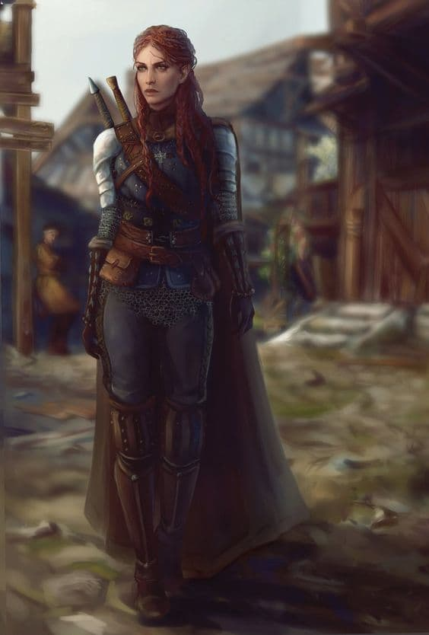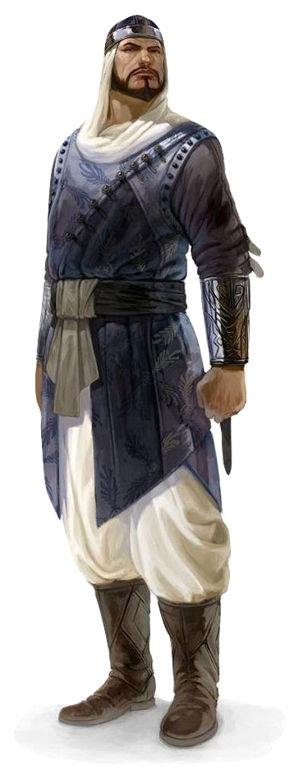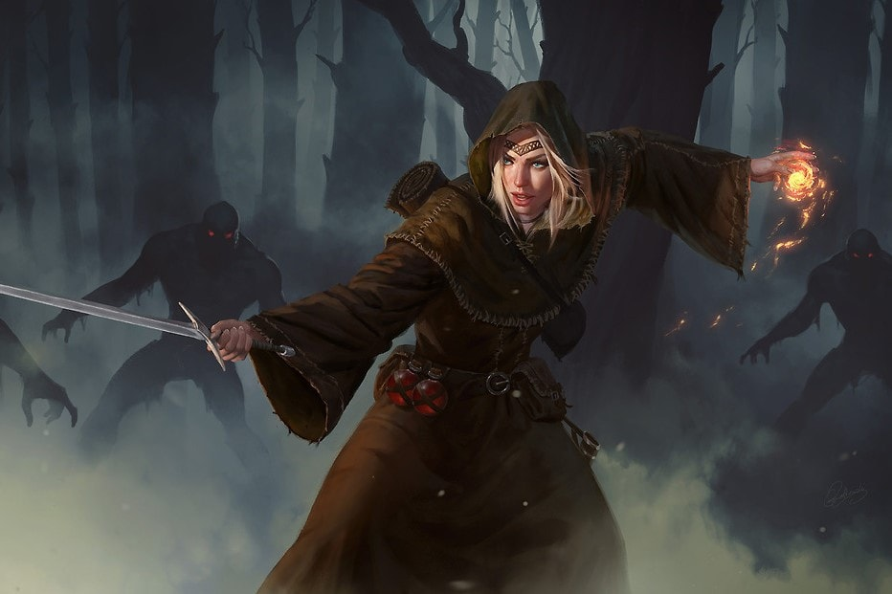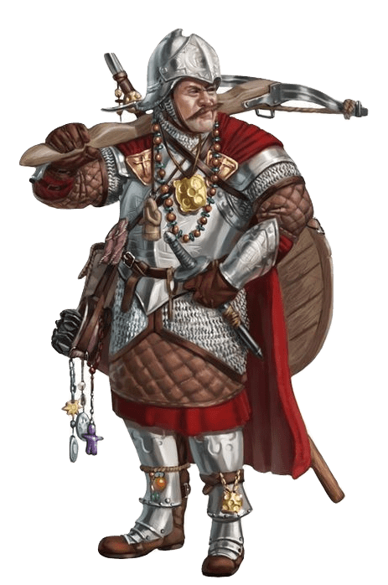

# Credit

I was inspired to create this document by u/zeek0’s [Homebrew Word Template.](https://www.reddit.com/r/UnearthedArcana/comments/6qtuuh/dd_style_word_templates_and_fonts_an_alternative/)

I basically picked the example images at random but here are the sources:

* [The half-elf woman](https://annahelme.deviantart.com/art/Aeronelle-667121578)
* [The sorceress](http://rpg-settings.tumblr.com/post/160099887267/ravensshire)
* [The guard](http://www.creativeuncut.com/gallery-19/acr-damat-ali-pasha-vizier.html)
* [The dwarven mercenary](https://rhineville.deviantart.com/art/Corwyn-Superstitious-Mercenary-339120381)

I made all the borders and watercolor splotches myself in photoshop with the photoshop brushes from the r/UnearthedArcana [library](https://www.reddit.com/r/UnearthedArcana/comments/3uwxx9/resources_open_to_the_community/).

The fonts are obviously all from the google fonts library. I chose the closest approximations that I could find.

# Terms of Use

You can use anything here. I don’t care. It’d be nice if you credited u/alittlegnome for formatting, but if you don’t I won’t be too sad.